Folder structure with notebook for logistic regression, Saved model .pkl file, Python code to run Flasgger:-

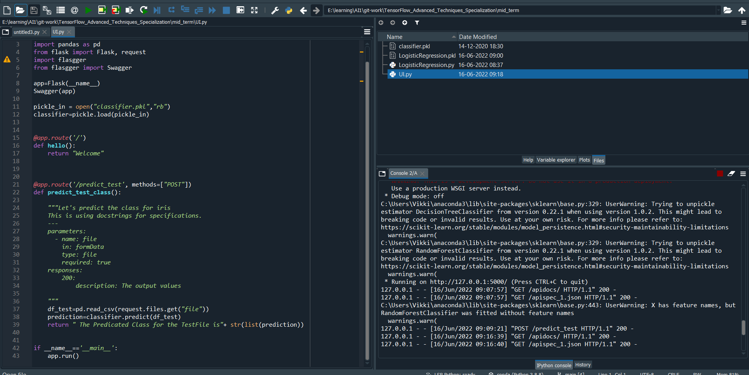

Swagger Interface:-

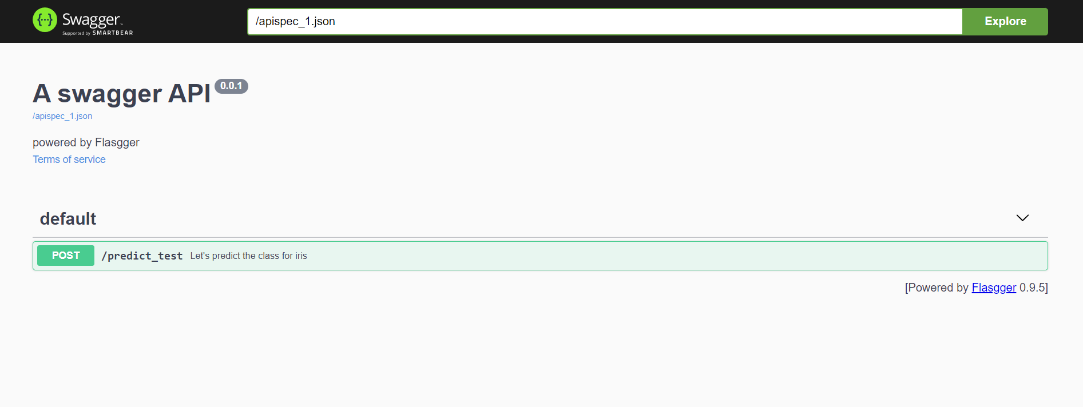

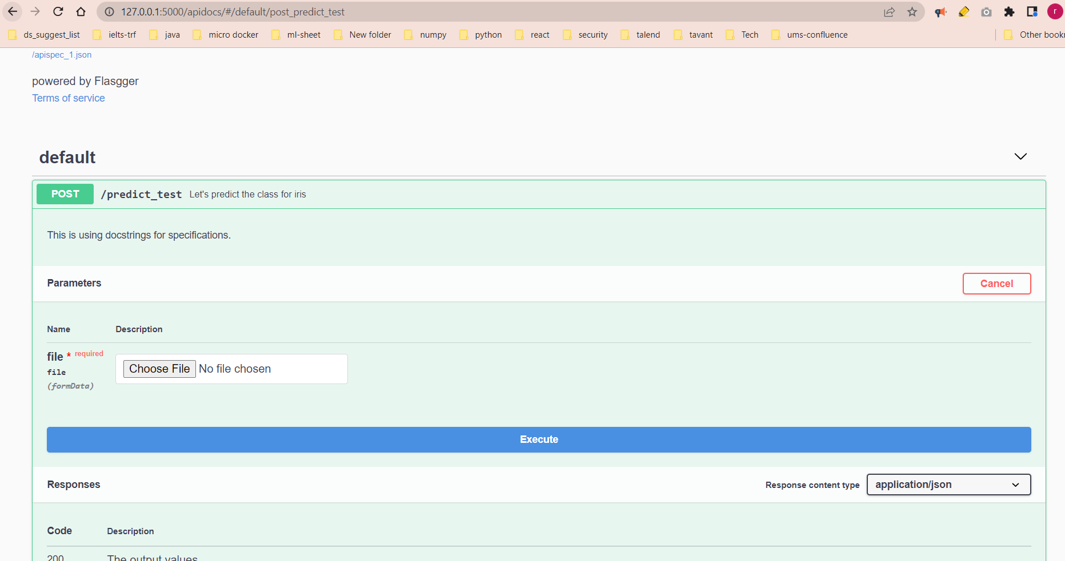

Screenshot of the prediction :

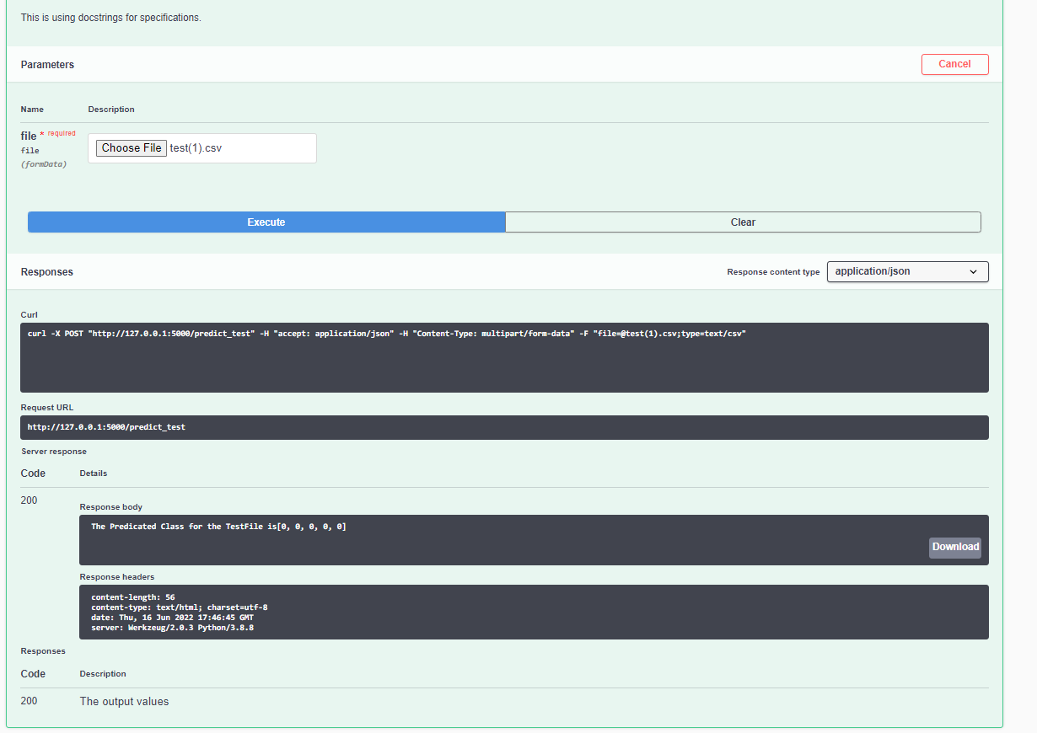

Answer 2 :- Git commad screen shot <https://github.com/kambojrakesh/TensorFlow_Advanced_Techniques_Specialization/tree/main/mid_term>

